Project Design Phase Solution Architecture

Date: | 11/02/2026
Team Id: | LTVIP2026TMIDS25023
Project Name: | Measuring the Pulse of prosperity: An index of economic freedom analysis
Maximum Marks: | 2 Marks

Solution Architecture:

Solution architecture is a complex process – with many sub-processes – that bridges the gap between business problems and technology solutions. Its goals are to:

- Find the best tech solution to solve existing business problems.
- Describe the structure, characteristics, behavior, and other aspects of the software to project stakeholders.
- Define features, development phases, and solution requirements.
- Provide specifications according to which the solution is defined, managed, and delivered.

Example - Solution Architecture Diagram:
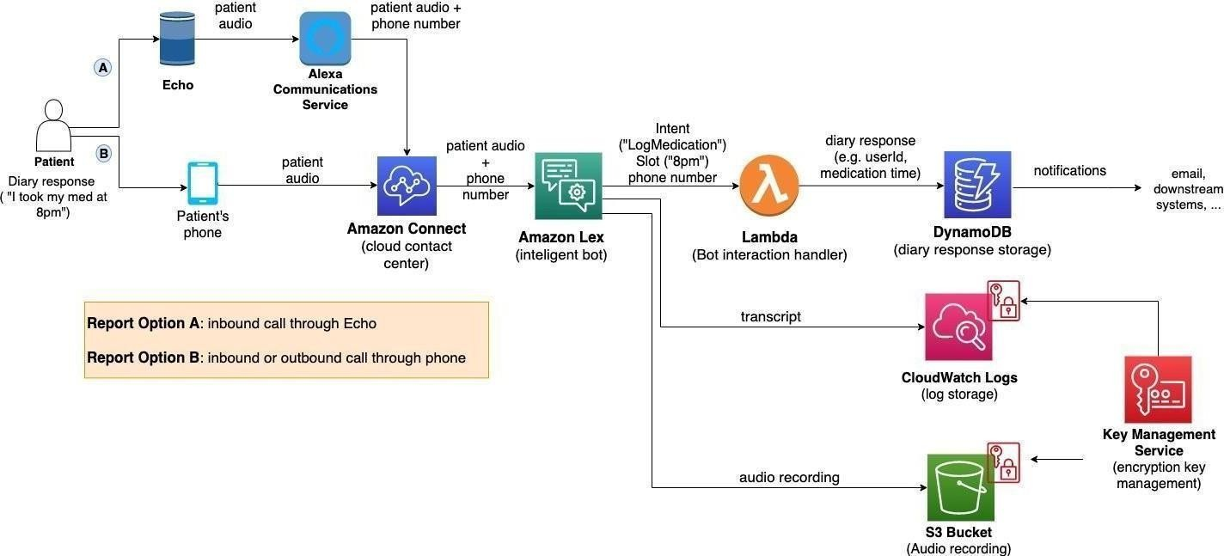

Figure 1: Architecture and data flow of the voice patient diary sample application

